TWO WAY TABLES
Pearson Edexcel - Tuesday 19 May 2020 - Paper 1 (Non-Calculator) Foundation Tier

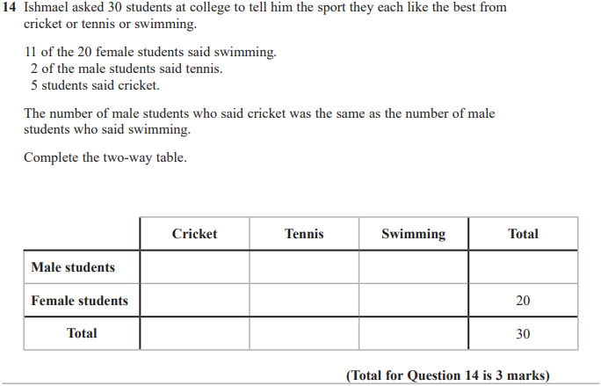

Pearson Edexcel - Tuesday 21 May 2019 - Paper 1 (Non-Calculator) Foundation Tier

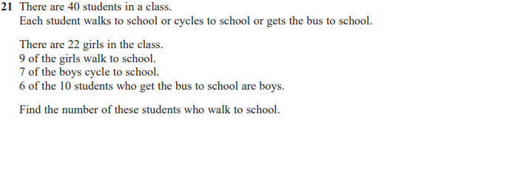
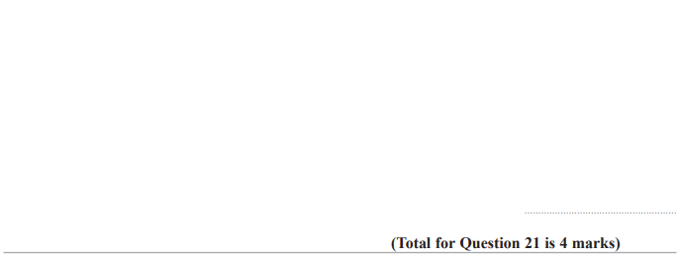

Pearson Edexcel - Thursday 2 November 2017 - Paper 1 (Non-Calculator) Foundation Tier

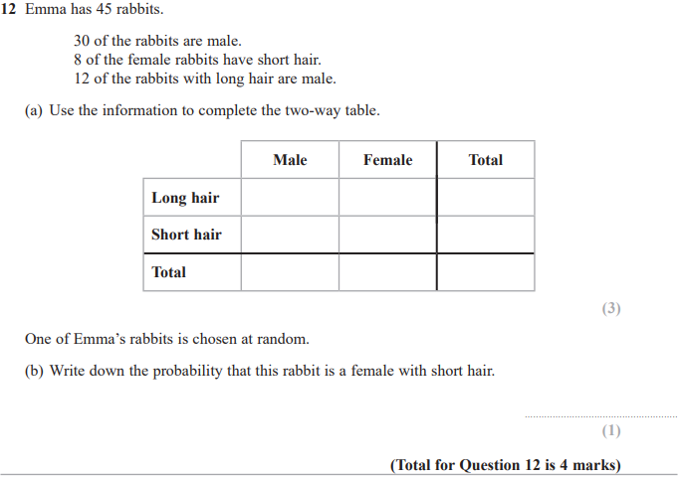

Pearson Edexcel – Specimen 1 - Paper 1 (Non-Calculator) Foundation Tier

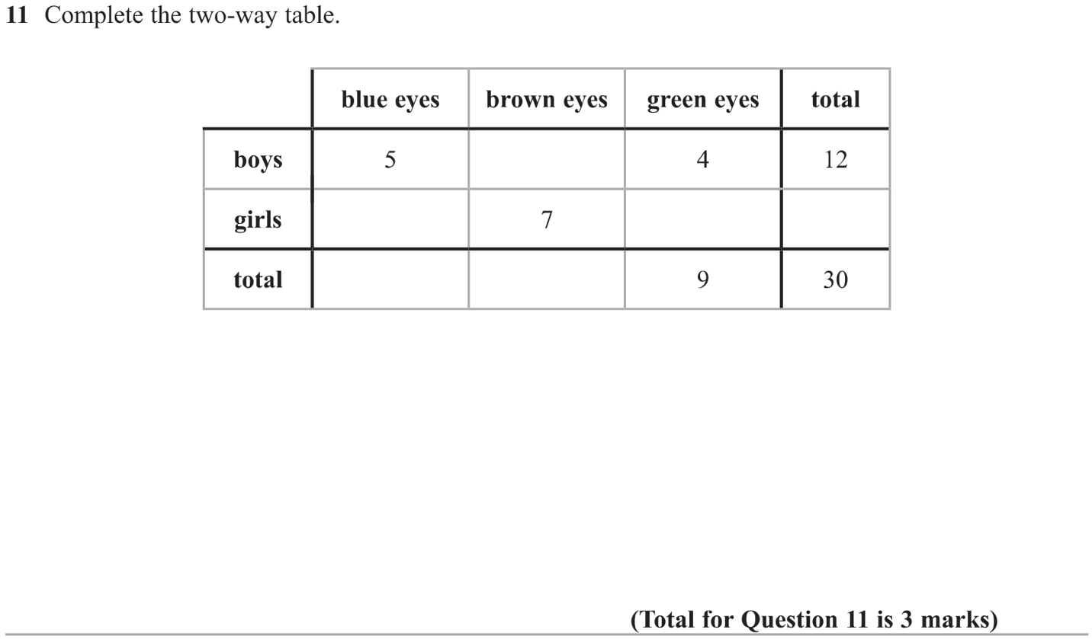

Pearson Edexcel – Sample Papers - Paper 3 (Calculator) Foundation Tier

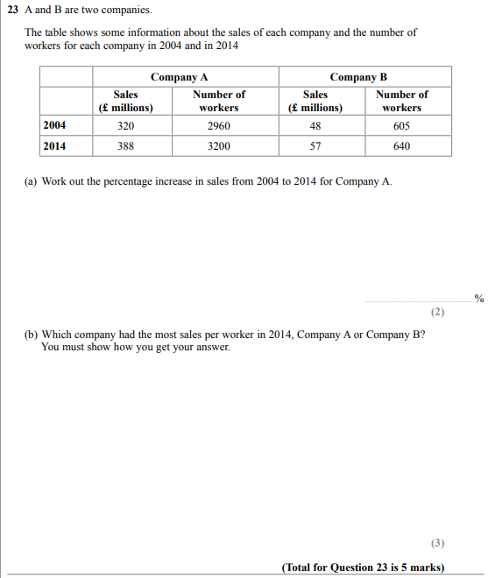

OCR Sample Question Paper 2 – Morning/Afternoon (Non - Calculator) Foundation Tier

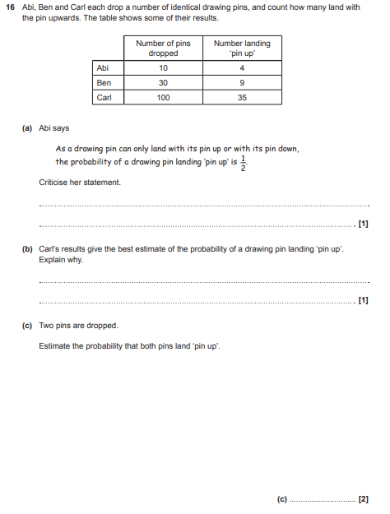

AQA Tuesday 19 May 2020 – Morning (Non-Calculator) Foundation Tier

